Problem 1:
Create a simple procedure to get all the records from the table ‘student_info’.
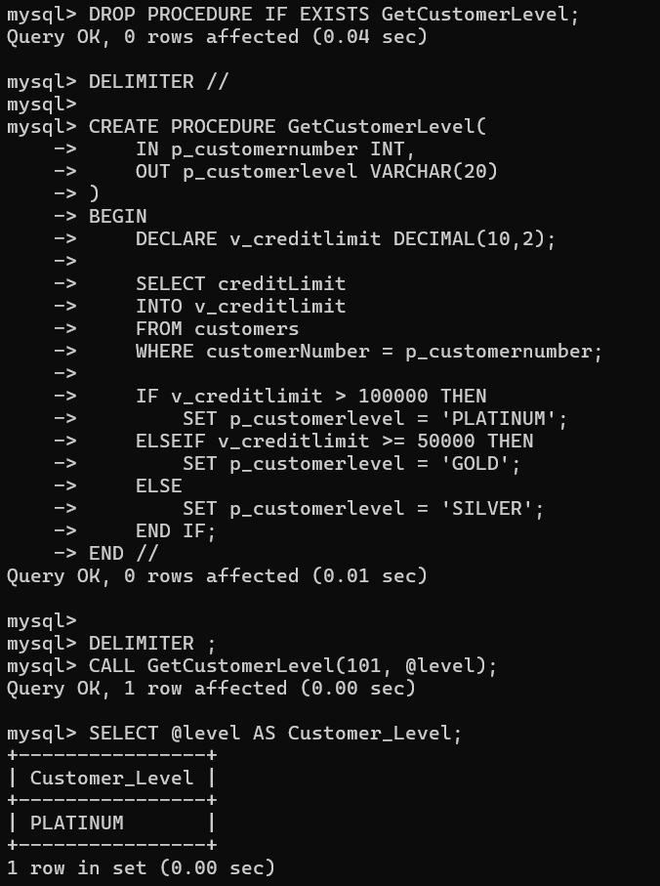

Problem 2:
Create a stored procedure GetCustomerLevel() that accepts two parameters customer number and customer level.
